Aug 27, 2025:
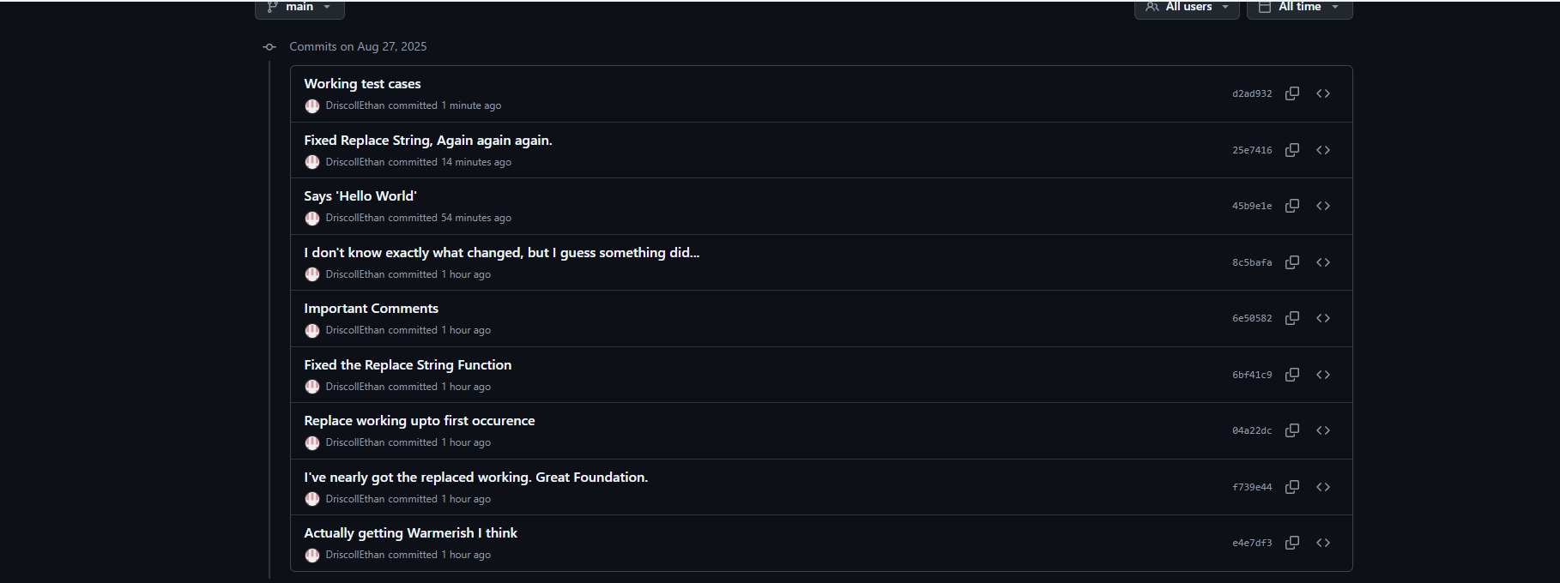
Aug 26, 2025:
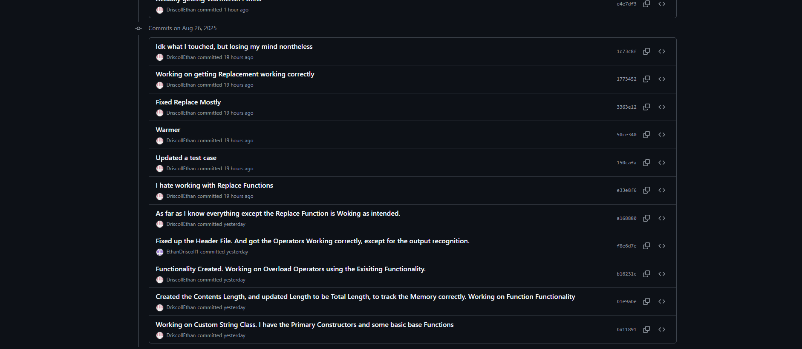
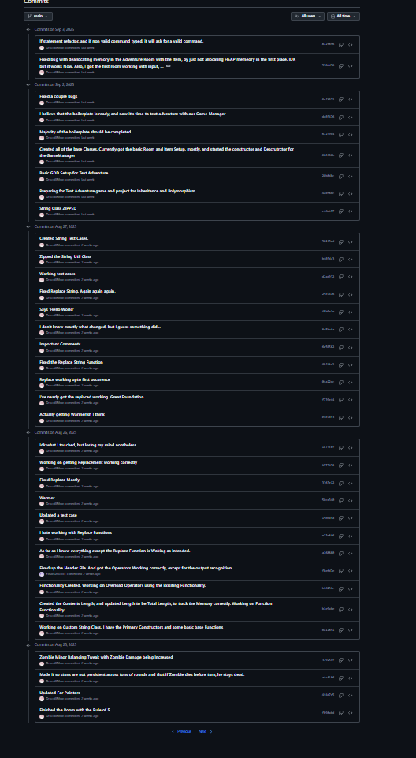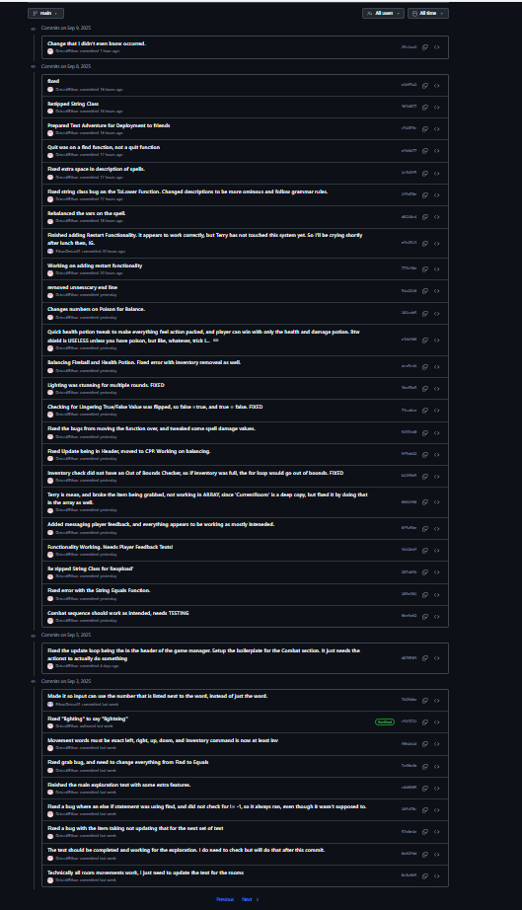
GitHub Repo Link: DriscollEthan/IntroToCpp: Course Work for Intro To CPP at AIE Seattle
Resource List: Previous Knowledge.
Challenges: Beginning my journey as a programmer at Academy of Interactive Entertainment in Seattle to acquire my Advanced Diploma of Game Programming, I started to work with Git on the command line, instead of just GitHub Desktop. I hand typed command such as, “Git Pull, Git Push, Git Commit -m ‘push title’, Git Add :/, etc.” At times I forgot to include the second quotation mark for ‘Git Commit -m “(title)”’, or other times I miss typed a word. To fix my issues, I would either restart Git Bash entirely, add the second quotation mark on a new line, or even retype the command from the start. Every error, unfortunately, took away precious development seconds that were imperative to my project’s success. Fortunately, I was able to push into overdrive to recover these lost seconds.

Weaknesses: As a relatively new user to working with Git on the command line, I don’t fully understand some of the nuances of the command line, such as being able to drag drop folders into the command line for the ability to get that file path quickly dropped into the command line. But I was able to figure out that I could open Git Bash within the folder, so it already references the folder address located on the hard drive. If I ever find errors, or need to know how to fix problems, I will research these problems by looking it up on Google, and checking Stack Overflow, and other developer websites, that may already have the solution I require.

